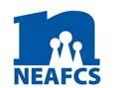
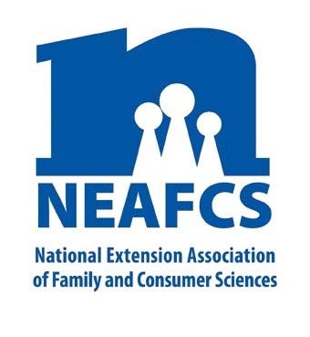

IMPACT 2014

Through Extension programs across the nation, Family and Consumer Science Extension Educators provide a multitude of educational opportunities to meet the needs of diverse audiences.

Protecting Our Resources – Family Life

Many American families struggle. They work hard, have limited resources of time, money and energy, often don’t have extended family nearby, and lack many household management skills. Extension Family and Consumer Sciences educators have developed and delivered a multitude of relevant programs that have strengthened contemporary family life. Highlighted here are programs that help support family relationships and family businesses, improve stress management skills, promote safe dating, encourage healthy parenting skills for all ages and phases, and encourage positive co-parenting through divorce and caring for family elder care providers.

Strengthening Families

Building Strong Families is offered throughout Missouri. In 2013, there were 156 programs, impacting 228 Missourians. Topics included Money Matters, Balancing Responsibilities, Managing Stress, Positive Discipline, and Kids’ & Self-Esteem. Co-Parenting Through Divorce classes were held in 17 Oklahoma counties, helping over 300 parents learn how to reduce the effects of divorce on their children.

NEAFCS National Office | 20423 State Road 7, Suite F6-491 | Boca Raton, FL 33498
(561) 477-8100 | FAX (561) 910-0896 | www.neafcs.org
In Kansas, military families are supported through projects and programs of Operation Military Kids. Forty-six programs at various military installations reached 483 families. Additionally, family programs reached 704 youth. One hundred thirty-three volunteers who assisted provided 450 hours of service. In an eight-hour training session, 25 Head Start Kansas

family service personnel were trained to help their
families build stronger family relationships.

In Michigan, 3,470 participants in 255 programs discovered and practiced social-emotional skills. A range of programs were offered such as RELAX: Alternatives to Anger, Building Strong Adolescents (provides parents and caregivers of teens with tools needed to help teens develop into successful adults), and Be SAFE: Safe, Affirming and Fair Environments, Safe Dates and Nurturing Parenting.

“The Family Caregivers Conference is offered annually for free – a gift for our community. Participants are both enthusiastic and grateful. The hands-on sessions by local experts give them confidence and skills.” -- Community Partner in Washington County, OR

Active Parenting Now and Active Parenting for Teens are part of the parenting skills and parent-child relationship program offered for Oklahoma families. Outcomes that improved by these programs for 1,368 participants include: parental attitudes and beliefs; parent–child relationship problems; and positive and negative child behaviors. In one group of participants who were drug court clientele, over half of the parents now have some type of visitation with their children.

Georgia is part of a multi-state cooperative that developed the Healthy Relationship Marriage Education Training curriculum. Four hundred eighty child welfare professionals were trained in 16 sessions by Extension staff to promote healthy couple relationships.

Utah’s Healthy Marriage Initiative was developed to help strengthen family relationships. Competitive grant funding was secured from Department of Workforce Services providing every county the opportunity to promote relationship building classes. Counties participating in the grant opened the series during Marriage Week – February 7-14. Additional classes were held on domestic violence prevention, strengthening relationships, Latino marriage education, and reinforcing family values. Over 280 programs reached more than 19,000 participants.

In Utah, 97 “How to Avoid Falling for a Jerk/Jerkette” dating education classes have been provided to 927 participants.

Nebraska’s Guardianship/Conservator Training Program helped state-appointed guardians learn to manage their finances, submit reports to the court, and fulfill other roles which impact the ward of the court. This court-mandated program is taught by four Extension educators state-wide. Since 2005 they have trained 7,200 guardians/conservators across the state and increased their ability to advocate for over 12,000 disabled adults or minor wards.

Maine Farm Families: Lives and Business in Balance is a factsheet series that features five different topics, focused on various aspects of agricultural farm life. The series has been accessed by 115 Maine families.
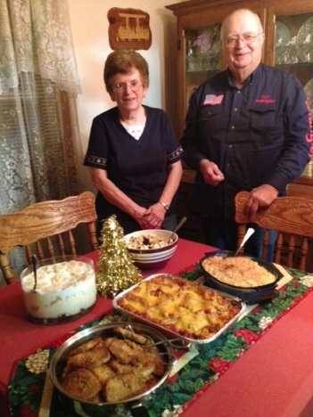

Aging/Elder Care

Seniors living in small, rural South Dakota communities do not have the same degree of access to health fairs
as do seniors living in urban areas. As a result of a conference geared towards elevating public awareness of the public and private services available to rural dwelling seniors, their families and caregivers, 100% of attendees increased their knowledge about fraud, waste and abuse; 95% about hearing loss; and 91% on the warning signs of Alzheimer’s. At the other end of the age spectrum, 179 youth at a South Dakota Operation Military Kids Camp, participated in activities that simulated the potential decline or disability associated with aging (low vision, reduced mobility, reduced tactile function, and hearing impairment) utilizing knowledge gained as they interviewed veterans.

A one-day annual Family Caregivers Conference in Washington County, Oregon for unpaid family caregivers featured a “Packing Your Caregiver Survival Kit” keynote address and six breakout sessions. Popular sessions included legal issues for caregivers, helping without getting hurt (lifts and transfers), communicating with the memory impaired, and managing medications. Partners were Disability, Aging and Veteran Services and Tuality Healthcare. This conference has been offered for the last ten years and has reached 1,700 participants.

In Northwest Kansas, a Full Circle Expo targeted professionals with in-depth sessions offering tools and information they could use with the communities they work in. An Aging with An Attitude Regional Expo was held in Southeast KS. Sessions designed for seniors included Bucket List and Looking Back, Legal Issues and Farm Succession, Who Gets Grandma’s Yellow Pie Plate, Meals for One or Two, and Conversations about Safe Driving.

This report was compiled by Glenda Hyde, Oregon State University Extension Service, Public Affairs Education Subcommittee member, and Theresa Mayhew, Cornell Cooperative Extension, Vice President - Public Affairs.
For more information, email tcm5@cornell.edu.

